

**12th EFRC CONFERENCE**

**August 24- 26, 2021**

**Warsaw, Poland**

**12th EFRC CONFERENCE**

[**WWW.RECIP.ORG**](http://WWW.RECIP.ORG)

**12th EFRC CONFERENCE**

**August 24- 26, 2021, Warsaw**

**DIGITALISATION AND AI**

**What's going on with my recip? How uncommon failure modes get detected.**

*by: Gaia Rossi, Thorsten Bickmann, Fayyaz Qureshi- Bently Nevada, a Baker Hughes business 87*

**Valve Data Acquisition throughout the Life Cycle**

*by: M. Schiavone, A. Raggi, A. Giampa, G. Ballerini- Dott. Ing. Mario COZZANI s.r.l. 97*

**Introduction of ElectronicControlPanelsinReciprocatingGasCompressor packages**

*by: Baruah Prateek, Oil India Limited 107*

**Pulsation Damper Optimization with AI**

*by: Jonah Poort, Can Timer, Pejman Shoeibi Omrani- TNO, Heat Transfer and Fluid Dynamics 117*

**Big Data Anomaly Detection Methods forReciprocatingCompressors**

*by: Can Timer, Jonah Poort, Pejman Shoeibi Omrani- TNO, Heat Transfer and Fluid Dynamics 127*

**PULSATIONS AND VIBRATIONS**

**Validation of Pressure Pulsation and Vibration Analyses in a Reciprocating Compressor for Design Optimization** *by: Cappelli Leonardo, Sacco Marco, Fusi Andrea- C.S.T. S.r.l.; Mazzoleni Thomas- SIAD Macchine Impianti*

*S.p.A. 141*

**Reduction of Vibration- Modal testing of a reciprocating compressor, theoretical background and practical testing**

*by: Thomas Heumesser, Ferdinand Marks - J.P. Sauer & Sohn Maschinenbau GmbH 149*

**Mechanical optimizationmethodologyforreciprocating compressor systems**

*by: Leonard van Lier, Paul Egberts, Can Timer- TNO, Department of Heat Transfer and Fluid Dynamics 163*

**The impact of system parameters on reactive damper transmission loss characteristics- experimental and simulation**

**approach**

*by: Warzy 175*



**Feasibility Study of a Novel ToroidalDamperConceptforImproved High Frequency Pulsation Control**

*by: Andre Eijk, Javier Fatou Gomez, Olaf Vijlbrief- TNO; Cyril Wentzel- Wentzel Dynamics 187*

**Improved plant reliability due to acoustical and vibrational optimisation**

*by: Dr.-Ing. Patrick Tetenborg, Dr.-Ing. Johann Lenz- KOTTER Consulting Engineers GmbH & Co. KG 197*

|  |
| --- |
| **CONTENTS** |



**What's going on with my recip? How   
uncommon failure modes get detected.**

|  |  |  |
| --- | --- | --- |
| **DIGITALISATION AND AI** | **87** |  |
|  |  |

**by:**

**Gaia Rossi Thorsten Bickmann**

Senior Application and Solution Architect, Senior Technical Leader for Recips,

Italy Germany

[gaia.rossi@bakerhughes.com](mailto:gaia.rossi@bakerhughes.com) [thorsten.bickmann@bakerhughes.com](mailto:thorsten.bickmann@bakerhughes.com)

**Fayyaz Qureshi**

Technical Leader for Recips, U A E   
[fayyaz.qureshi@bakerhughes.com](mailto:fayyaz.qureshi@bakerhughes.com)

Bently Nevada, a Baker Hughes business

**12th EFRC CONFERENCE**

**August 24- 26, 2021, Warsaw**

Abstract:

According to the EFRC Compressor Reliability Survey, the primary causes for reciprocating compressor unscheduled shutdowns include faults at valves, pressure packing, process problems, piston rings, rider bands and unloaders.

Modern condition monitoring technologies provide key information to pinpoint to malfunctions at those components and enable effective operating and maintenance decisions.

This paper describes several case studies where condition monitoring information helped in identifying piston rings failure progression, loose and leaking valves, stepless unloader problems, hyper compressor valve malfunction and process related issues. More case studies highlight the significance of horizontal rod position measurement and dynamic analysis in detecting uncommon failure modes, such as partition packing failure, uneven crosshead wear and microscopic cracks, which typically get identified only during major inspections.

Those cases show the importance of adding specific instrumentation to standard safety measurements, not only to assess performance, but also to promptly identify developing issues.

Rapid return on investment from monitoring systems adoption is achieved when maintenance strategy moves from preventive to predictive providing the ability to operate in a more reliable and predictable way and extend the period between outages.

**DIGITALISATION AND AI**

*by: Gaia Rossi, Thorsten Bickmann, Fayyaz Qureshi- Bently Nevada, a Baker Hughes business*

**1 Objectives of a condition monitoring system**

Reciprocating compressors, being the lifeline of most mid-stream, downstream and petrochemical facilities, are well known for their flexibility but simultaneously notorious for unanticipated expensive downtimes and catastrophic failures. To avoid such incidents and production loss, OEMs and operators have set strict timelines on routine checks and overhauls based on operating hours following preventive maintenance strategy. These periodic inspections are expensive, due to resources required in scheduling and execution and the inventory built-up to have all spares available onsite, causing extensive overheads.

At the same time, the priorities in oil and gas industry include improving safety, reliability and availability and require operators to install an online condition monitoring system to ensure safe operation and prevent catastrophic failures.

The adoption of such systems also enables the implementation of a condition-based maintenance program to perform focused maintenance just on the specific components that need it, while minimizing downtime. Operators want to detect gas leaking and failures in the running gear at an early stage.

Additionally, an online condition monitoring system allows to visualize key parameters as indicated cylinder pressure and synchronized vibration, to provide the full picture of compressor health and performance during critical phases as commissioning or post overhaul.

**2 Machine faults, which are detectable by a Condition Monitoring System**

A compressor reliability survey has already been carried out by Dresser-Rand approximately 15 years ago and was published in an EFRC R&D project including a Compressor Reliability Survey [1] (in European Forum for Reciprocating Compressors e. V.). In this survey 217 questionnaires were distributed worldwide and 62 were returned (response quota of 28.6%). The results of this survey are summarized in Figure 1, which illustrates the reciprocating compressor systems and components identified to result in unscheduled shutdowns. According to the results, eight systems and component areas are responsible for nearly 94% of all unscheduled shutdowns of reciprocating compressors. One interesting result was the ranking of the cylinder lubrication system as one of the top eight problem areas. This was determined to be significant as the reliability of the systems can directly affect the reliability of three other components also ranked among the top eight problem areas: pressure packings (#2), piston rings (#4) and rider bands (#5).

*Figure 1: Components causing unscheduled shut­down on reciprocating compressor [1]*

As shown in the figure above, valve failures are the most common issue on reciprocating compressors, and they contribute to most of the maintenance cost.

Online access to the internal pressure measurement for each compressor cylinder enables continuous monitoring of compression cycles, compression ratios, peak rod loads, and rod reversal. This provides valuable information on the condition of suction valves, discharge valves, piston rings, packing glands, piston & piston rod connection and crosshead pin. In addition, the functionality of capacity control devices, such as unloaders, clearance pockets and stepless control systems can be analysed.

From a diagnostic standpoint, dynamic cylinder pressure measurement provides great value. The ability to correlate events in the crosshead acceleration waveform with events in the pressure, rod load curve and crosshead vertical force is essential. This enables efficient decision making, regarding the parts that need to be replaced.

An indicated cylinder pressure versus crank angle plot provides a quick reference to identify leakages/failures on valves from the very outset. Valve cover temperatures start showing increasing trend once the valve leakage becomes severe.

**2.1 Valve leakages**

On a six-throw compressor unit, high frequency accelerations were noticed in the crosshead vibration versus crank angle plot (Figure 2). These high frequency components appeared when the crank end (CE) suction valve was closed, and gas flow was producing a high frequency sound ("hiss"), which was captured by the crosshead accelerometer across the same throw [2]. The cylinder dynamic pressure versus crank angle plot on CE chamber also showed a deviation between actual and ideal pressure curves, i.e. actual pressure was rising slower than expected, which signified the presence of gas leaking into low pressure areas (either gas leakage through suction valve into suction bottle, or gas leakage through pressure packing).

Components causing unscheduled shutdown for reciprocating   
cumwessurs

|  |  |  |  |  |  |
| --- | --- | --- | --- | --- | --- |
| 10 | |  |  |  |  |
| 15 | |  |  |  |  |
| 30 | |  |  |  |  |
| y  a  20  10  0 I I"  ***de 4/***  44 e'44 |  |  |  |  |  |
|  |  |  |  |  |
| 7.1 G.EI G.0 5, 5, 3i4  IIII I I I 1m3  ***,O; •*** ,1* | 0.7 | A 4  *•* | 03 | 02 02 |
| *0.* | 4'  , |

* e

*by: Gaia Rossi, Thorsten Bickmann, Fayyaz Qureshi- Bently Nevada, a Baker Hughes business*

|  |  |  |  |  |  |
| --- | --- | --- | --- | --- | --- |
| **•** | | | **-p•s,0 ••••,130••** | * **• 24,1)041 ktt,33 *46.*** | |
| * **Oa 3•10•1** | **••••••••••••R** | **Paw •** | **411.• ft. IT, • •** | * **•SnIrate nt1.•** |  |
| * **CV WI,** | ***raw*** | **MI,. •** | * **S Mr (s) • e• • •** | * **• LIMON 32.12** |  |
| * **01.Pal** | ce **P•s•••** | **MI,. •** | * **1•1••• (2)• V PC t.VI • •** | * **• ialtiOle** |  |
| **.3•4•r** | **••••••••** | ***••••*** | **lim• V lig • •** | * **• IMMO 1,11,23.** | **.lo** |
| * **06 "dyne** | **•••••••** | **flew. • 18.9181•• (1114, ••, lig • •** | | * **• MAIM htt:•** | **•** |

**14.**

*Figure 2: High frequency leakage sound captured by crosshead accelerometer, when CE suction valve is closed. Dynamic pressures confirm CE suction valve leak additionally*

The suction valve cover temperatures were checked too, and the temperature of suction valve on crank end was found significantly higher than that at the head end. Thus, a packing leak can be excluded. Maintenance teams were advised to check the suction valve on CE and the valve cage was found broken, causing severe leakage.

**2.2 Valve failure detection at a Hyper Compressor**

Health monitoring of suction and discharge valves at a hyper compressor can be easily achieved by acceleration measurements at each cylinder.

The normal occurring impulses generated by valve opening and closing are plotted for one revolution in the next figure.

The broken spring lead to strong opening and closing impacts of the suction valve, which also lead to a saturated acceleration waveform (Figure 4).

**BMW' •**

* [com.c.cl](http://com.c.cl). **• Auffett722.1, • 224 ms. •** 1.213•*r **I .1.1.,2911 2.34.15 1.1. • •   
  1**

**Strong Valve impacts lead to saturated acceleration** WOVeforn,

**High Suction**

**Valve opening**

**im** Valve closure

Strong Suction knock

**I.**

**1.1 • •**

*Figure 4: Impulses measured at the valve of a hyper compressor in bad condition*

The banded waterfall diagram shows the developing trend of the vibration over the time (Figure 5).

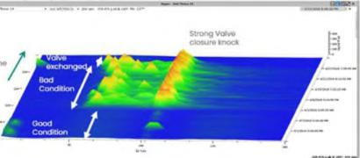

*Figure 5: Waterfall diagram of cylinder vibration measured at the valve of a hyper compressor over time*

**3 Significance of Horizontal Piston Rod Vibration Monitoring**

**re,**

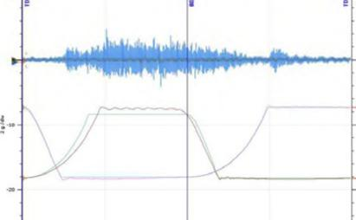

**4** li

* ***er***

Experiences have shown that having a single sensor installed vertically across pressure packing, cannot provide comprehensive information about movement of piston rod throughout the revolution. Thus, several primary malfunctions cannot be detected due to the absence of a horizontal rod position probe, until these cause secondary expensive failures triggering high frame (crankcase and crosshead) vibration; a few of these malfunctions will be shown in the following subsections.

The forces caused by gas compression and the inertial forces caused by the running gear movement are in line with crankshaft main bearing axis, for which frame vibration sensors are installed to detect any abnormalities.

Any abnormal crosshead movement in vertical direction and impacts generated by looseness are picked up by a vibration sensor installed vertically on top of the crosshead casing. But if there is no monitoring at the horizontal direction of the piston

**Suction   
Valve   
closes**

**Suction   
Valve   
opens**

**NINO**

**- IL .1. 3311,10 MI • •**•

**•• l••• Mo. I•**



**.1•11 470**

*Figure 3: Typical impulses measured at the valve of a hyper compressor in good condition*

In this example the valve spring broke and the measured acceleration changed drastically in amplitude and signature.

**DIGITALISATION AND AI**

*by: Gaia Rossi, Thorsten Bickmann, Fayyaz Qureshi- Bently Nevada, a Baker Hughes business*

rod, then an abnormal horizontal movement in the running gear cannot be captured.

Piston rod peak-to-peak vibration has proven to be an early and the only indicator of developing cracks in the piston rod. On the other hand, crankcase and crosshead vibration increase significantly, only when the piston rod is already disconnected.

Having said that, piston rod flexing/bending significantly depends upon the location and axis of the crack. Perpendicular cracks will show up as high piston rod vibration in vertical axis and can be picked up by vertical rod position probes as mentioned in API 670. However, lateral cracks will show up as increasing horizontal piston rod vibration, which can only be picked up by a horizontal piston rod position sensor.

Failure modes such as partition packing failure, uneven crosshead wear and microscopic cracks at the piston rod, which are usually identified during major inspections can be determined during machine operation by analysing dynamic data of the condition monitoring software.

**3.1 Running gear misalignment is leading to uneven crosshead wear**

The alignment of motor and crankshaft of a reciprocating compressor train is part of the preventive maintenance check. To ensure that any severe misalignment is captured during operation, vibration sensors are installed on motor bearings and compressor crankcase and alarm/trip is set to save machines from severe damages and expensive repairs.

The vertical alignment ofthe running gear (connecting rod, crosshead, piston rod and piston), is typically monitored by crosshead vibration sensors installed vertically on top of crosshead guide. Vertical rod drop/position proximity sensors are installed at the pressure packing flange to detect any abnormal vertical movement of the piston rod and alarm/trip when parameters exceed pre-configured setpoints.

However, if there is any abnormal horizontal movement of the piston rod in the horizontal plane, the only sensor/measurement that can detect this variance would be a horizontal rod position sensor. The following case study shows how an online monitoring system can detect a misalignment in the running gear which historically could only be witnessed during a machine overhaul.

On a Diesel HydroTreating Unit in a refinery, 3 trains of 4-cylinder recycle/makeup gas compressors (2 running, 1 standby) are used to raise pressure from 26 barg to 85 barg for makeup in two stages and to raise pressure from 54 barg to 85 barg for recycle. These machines are equipped with an online condition monitoring and protection system and a

resident engineer is available onsite for system management.

The machines are monitored for motor bearing vibration, crankcase vibration, crosshead vibration, vertical and horizontal piston rod position and peak-to-peak vibration, cylinder chamber pressure monitoring, rod load analysis and performance monitoring and keyphasor probe with multi-event wheel for accurate crank angle reference.

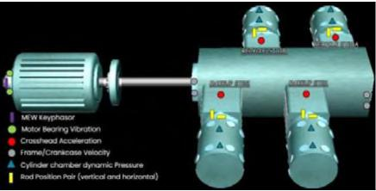

*Figure 6: Sensor Layout*

In March 2019, the peak-to-peak piston rod vibration in horizontal direction increased gradually from a nominal value of 200µm pp to 500µm pp (where alarm was set at 400µm pp).

*Figure 7: Crosshead vibration trend (top) and peak-peak displacement trend in horizontal and vertical direction (bottom)*

Since the actual movement was in horizontal direction only, no apparent change was observed in vertical piston rod vibration and/or crosshead vibration since crosshead vibration sensor is installed vertically, as shown below in Figure 8.

|  |  |  |  |  |  |  |
| --- | --- | --- | --- | --- | --- | --- |
|  |  |  |  |  |  |  |
|  |  |  |  |  |  |
|  |  |  |  |  |  |
|  |  | . mum 05  te | | | |
|  |  |  |  |  |  |
|  |  |  |  |  |  |
|  |  |  |  |  |  |
|  |  |  |  |  |  |

*Figure 8: Crosshead vibration sensor mounting*

The horizontal movement can happen either because of horizontal movement of piston inside cylinder, or because of unusual horizontal movement of the crosshead within its guide. The piston can move horizontally if there is any load change or piston rings get damaged and broken particles get trapped on the sides of piston causing horizontal movemement.

When referred to the second dynamic cylinder

.qmit A4411644O oil 0 164

**W;* •Vpiiinnent) "...me amnion On Mal**

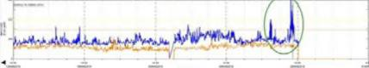

D.

|  |  |
| --- | --- |
|  |  |
| **DIGITALISATION AND AI** |
|  |

*by: Gaia Rossi, Thorsten Bickmann, Fayyaz Qureshi- Bently Nevada, a Baker Hughes business*

pressure vs. crank angle plot in Figure 9, both head end (HE) and crank end (CE) chambers are fully loaded, confirming no/partial load changes. The ideal (adiabatic) and actual pressure plots are mostly coinciding (CE shows slight suction valve/pressure packing leak) confirming that there is no piston ring failure (in case of failure there would be a crossover between adiabatic and actual curves).

Hence it was concluded that there was an unsual horizontal movement of the crosshead within its guide, also evident from the bottom plot in Figure 9, showing the horizontal piston rod displacement fluctuating throughout the revolution and from rod position plot in Figure 10, showing the piston rod movement to be primarily horizontal and fluctuating.

*Figure 9: Dynamic plots in crank angle domain*

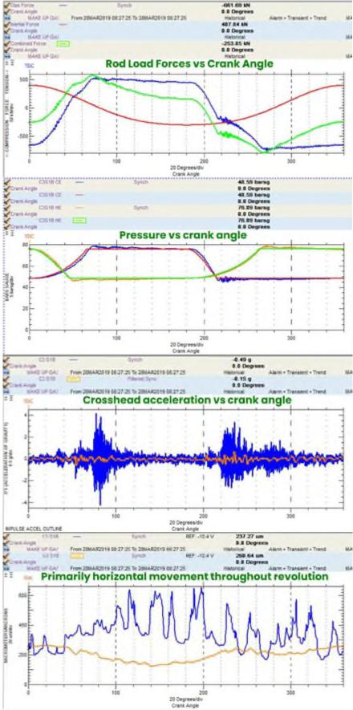

•••

**0•••• 440**

**•• o.**

iT **0•4 4G. rom..1.12.10 V21 2 *M4.40.111.* 2 411•42. •**

* **Primarily horizontal movement throughourevolu**t**ion**

**%MAI Um 2.0 40•440.04.1 tell 2 Om *MAI\*\** r•at PIS**

**••••• —**

**Rod Load Forces vs Crank Angle**

***211***

i.**a.••M.**

***Owe***

**21111... 021121. 44 SOME. O. 011.1.0**

**.• r.**

* **0 040. 1.40**r. **0 0 0.2•••**

**Pressure vs crank angle**

***710***

**20 Co.201.1•**

**J4..**

**.11 121.21.•**

***floplagaNTEI.311.A.I*Mr. Ma..* blam• mo0.04. • •.•••• 0**

**4 r.**

**4 001M**

**1. MOON 40 V .2 vataniarm *...... ..a•* 71.••••• • TOME Ill.**

**Crosshead acceleration vs crank angle**

**•**

***20* C•noi**

.•

***06.,•••••***

**KT • •1 • •• OW.=**

**40.••••**

**4•41110022410,10 2...11204 2.2,11 mom.. 00s,noreo • Ord**

* **V MIN .4**

0

**O.. 1•••• .4. be 0•••••••• 42•••••••.,••••• 100 6.•••., o•-•**

**..../ •-, ... CI .,.., .01•• •••14, *Marl***

***Cla ,... .... Comm., to •***

**11, *a.* imaiNIMMI1** •**19$ OM MOWN, Maso • 0.2.0 • ..0**

**0.4.0000,10.2**

|  |
| --- |
| 1 I I 1  I ; |

*Figure 10: Rod Position plot showing horizontal   
and fluctuating movement*

The maintenance team was asked to inspect the crosshead on cylinder 3 and to check the running gear alignment across the connecting rod and the piston rod connections on either end. During a physical inspection, the crosshead bottom shoe to guide clearances were measured as shown in Figure 11. The clearance should ideally be zero but significant clearances of around 5 mils were measured towards the frame end.

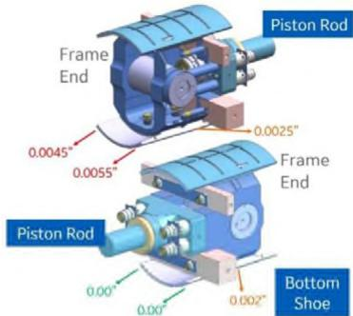

*Figure 11: Measured clearances on crosshead,   
displayed measurements are in inches*

After performing further run out checks and after verifying the connections, it was observed that the connecting rod was not properly aligned, because of an offset between the crosshead pin and bushings. This was causing the unusual horizontal movement and resulted in uneven crosshead wear. Early detection of this unusual failure mode from a non-conventional parameter (piston rod vibration peak-peak displacement) and the advised decision of performing condition-based maintenance (CBM) instead of waiting for time-based overhaul window saved the machine from expensive repairs and extended downtime.

**3.2 Loose partition packing**

The machine operator carried out a 16,000 hours major overhaul in the presence of the OEM, to ensure all procedures and checklists were followed thoroughly; however, the possibility of human error can never be completely eliminated.

**DIGITALISATION AND AI**

*by: Gaia Rossi, Thorsten Bickmann, Fayyaz Qureshi- Bently Nevada, a Baker Hughes business*

It was reported to the machinery diagnostics resident engineer that within 10 minutes of machine startup, the rod position magnitude changed by over 1000 µm and the horizontal piston rod vibration increased drastically. The customer requested to review the data and to evaluate whether the machine could be kept running, suspecting this to be an instrumentation issue. The machinery diagnostics engineer advised to shutdown the machine to avoid further damage.

**431, MS Ss   
00 Oman.**

**mares Sam • TWO. • 11•11**

**WS, 101**

**110**

**oases..**

**.2110 101**

* **0 •••••••**

**Rod Load Forces**

|  |  |  |  |  |  |  |
| --- | --- | --- | --- | --- | --- | --- |
| ***a....***  **.** | **4.11•**  **4,5,4a 410,4 CI**  **S, 1.** | **0 11111••••**  **0111)••••••**  **— a MI loomi**  **II. a.m.**  ***II i .211 04...I"* .. Sasma•**  **Pressure vs crank angle** | | | | |
|  | **.** |  | |  |  |  |
|  |  |  |  |
|  | **.** | | |  |
|  |  | **, .**  **..„—..  c........** | | | | |
| ***II***  **4 i ......** | **.**  **ps ,I.IIIIS.**  **simit**  **"'"**  ***O*.. II.** | * **..**   **0 4 0.001**  **,..• MGM'S ,,= IrSE•Stne,1 Pr." .....:. • sr. • 'moo. • ,,,•• IL**  **Oft•**  **-.. <Mim ....-2,‘ ORM mA,II ,, 4'...4 O. •••••••**  **Crosshead vibration**  **i** | | | | |
|  |  | |  | **........** | |
| **11111,141.31. 041:11** | **WOK** | **.0. 21.; to**  **2000.1•00.  Cm. ••••** | | | | |
| **D. sr.**  **OK..**  **10.4 WOO!**  **. NA**  **aams**  **WO IN *OW*** | | **— .07 -104 V Wawa**   * **• 13.••••**   **\*MM. TIMIlimall.14111,.11434 noise. AIM .1•••••• 0.4 14**  **sr-, Nal -lily &ninon**  **SA Moan**  **11•0018•00.s112131,•01!"."1,111S, MN,. Ya•Y.01.1.0 IM**  **Piston rod displacement**   * **•** | | | | |
|  |  | **I t t** | **t** | | | |
|  |  |
|  | **,**  **t**  **i  I** | | | |  |

*Figure 12: Dynamic sample upon starting compressor @ 11:22am*

The machine was restarted around 11:22 am and all parameters seemed to be fine, as shown below in Figure 12. The top rod load forces plot showed adequate rod load reversal; combined rod load forces of 600kN in tension and 8001N in compression were well within rated values of 13001N and 15001N respectively. The third part of the figure, the crosshead vibration vs. crank angle plot displayed no significant impacts in the filtered waveform, which confirmed no mechanical looseness in the running gear. The dynamic pressures curves in the second

part of the plot were aligned perfectly with the adiabatic (ideal) plots confirming an healthy cylinder trim (valves, pressure packing, rings) condition. The piston rod vibration and displacement were normal and within the limits in the bottom piston rod displacement vs. crank angle plot.

The horizontal piston rod peak-to-peak vibration started to increase, and within 9 minutes the peak-to-peak displacement in horizontal direction reached over 1000 µm, as shown in the bottom right quadrant in Figure 13. All other plots showed the same condition as before: no developing mechanical looseness in the running gear and no apparent issues in the cylinder trim.

**R.114••••• — 0.4.0**

**•••• .....11•11MIII n 3. 44 1, IMMO.* yr,...erce**

**use,**

**oaumou•ana**

**.r.••••••••**

**$10 *Wkl, VP QM:***

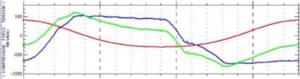

a.

**C.o. on**

|  |  |  |  |  |  |
| --- | --- | --- | --- | --- | --- |
| ***II'l".***  **••••**  **ViSto 4, —**  **.10**  **[Moor**  **4.4**  cal..  **.sr**  **.,** | | | | **WIS. 1,4416**   * **•  1111a...Y..** * **• 0..,•••**   **7. _..q**   * **• •••••••  17.111....  00 Ossasma** | |
| **1 '**  **i.. .1-** |  |  | |  | |
| **—** |  | |  |  |
|  |  | |  |  |
| ***6'..***  **r.**  **,** | **2.0 14 0....,\***  ***Uwe An-***  **mooeurio. P.m *011041.0.11* I I I* 2411, 41,411.211,. 11, V WI 4,010**  **ars lora.. O.41011.1,01,11 II 3, Si Te OWN i• .1119 4.**  **- *1*** | | | ***VI 00.••••***  **4 NM s  t • •••••••** | |
|  |  |  | | ***\*/".0"14144"r*** | |
| **WAS 44140.044.1,4**  **m 2.0.....414**  ***Urn Y.*** | | |  | |
| **6-4 WK. WOW 000..W.04... 11 )1 0. re**  *.,.... ‘,.. :---*  **lb - ...WO.: ammIS4024,1, tl ,, 0. A**  **a...**  **i** | | | **-...**  **ND • UV**  **NWT. 11,104**  ***OD* .10 a V**  **0•11,2M,M II 1,1 *04*** | **"MO sm  SS Swam**  **N.. Yen ,r0,42,14. • IA* Id  1SISII an**   * **• 0•••••**   **IsManal Yrs • Iowa • Tnat a** | |
| **S tam**  ***!*1 al**  ***it***  **i .r0*_***  ***40..*** | **'**  **.** | | **1200UM PP:** |  |  |
|  |  |
| ***I***  ***I*** | | |  | |
|  | | |  | |

*Figure 13: Dynamic sample @ 11:31am (9 minutes after starting up)*

The piston rod position magnitude increased from 700µm to 2800µm; the position angle (direction of movement) was primarily horizontally left, i.e. 270 degrees, when viewed from the crankshaft towards the cylinder as shown in Figure 14. This movement was suspected to be caused by a force acting in horizontal direction. Since the compression

— _

***•••***

***fl....***

***I* Or . masullIPSO*1.122a•IIIPMPO II Slat**

**mos —**

**YAW 'Paw**

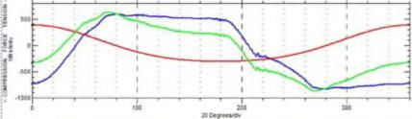

1101

**a.111   
Oa Call.•••**

**11•11,000 .11.0•41,••••••••••• SWAMI**

**111mass•   
*nos   
41110   
I • Ilmans•**

**IMMO Ka**

I **DIGITALISATION AND AI 93 I**

*by: Gaia Rossi, Thorsten Bickmann, Fayyaz Qureshi- Bently Nevada, a Baker Hughes business*

chambers were loaded and no piston ring leak showed up, that lead to the confirmation that no piston ring loose pieces caused the horizontal movement of piston.

The horizontal probe was installed 90 degrees left for this cylinder. Due to the significant movement of the piston rod in horizontal left direction, the gap voltage decreased (as shown in Figure 15).

|  |  |  |  |  |
| --- | --- | --- | --- | --- |
| **ft i'**  **4**  **I**  ..'g.. |  |  |  | |
| **l.- —** |  |  | **,** |
|  |  |
|  | .W4. | -1. .;.1. | |

*Figure 15: Horizontal probe gap voltage trend over*

*time*

The blue plot in Figure 16 represents the piston rod position and movement when the machine was started. The orange plot shows the piston rod trajectory over one revolution when the piston rod was forced to move horizontally left.



*Figure 16: Rod Position Plot (blue — normal &   
orange — failure)*

Upon opening the inspection windows, the partition packing tie rods were found loose, thus forcing piston rod to move horizontally left and to hit the probe, damaging tip completely. The pictures in Figure 17 show the rubbed piston rod and the damaged partition packing.

Upon careful data analysis, informed decision was made to safely shut the machine down, avoiding secondary expensive repairs and extended downtime.

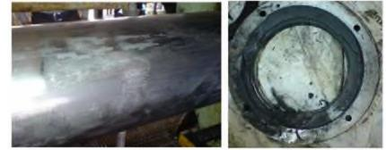

*Figure 17: rubbed piston rod and damaged   
partition packing*

**3.3 Piston rod failure**

To meet a hydrocracker capacity requirement, three out of four make-up gas compressors have to be operational. All machines are monitored with a proactive condition monitoring and protection system comprising of crankcase vibration, crosshead vibration, piston rod position and vibration (vertical and horizontal), cylinder chamber dynamic pressure measurement„ rod load analysis and performance monitoring and multi-event wheel keyphasor for accurate crank angle reference.

CS 1

**I NM KIYPhClee,**

**MOW 011•19 V115.1101,   
9 Cradled] AccRisollon   
fromdCronbcdes Neektuty**

**CVI chambRr chromic Pressure   
IRod Pooten Par (vertled cvnd horizontal)**

*Figure 18: Sensor Layout*

One morning, the crankcase vibration of one of the six-throw make-up gas compressors suddenly increased from a nominal 3mm/s pk to 41mm/s pk within a second and tripped the machine. The magnitude was higher for the velocity sensors installed near the pump end (NDE) of the compressor. However the amplitude at the sensors on the driving end was also higher than alarm setpoints (Figure 19).

|  |  |  |
| --- | --- | --- |
| mimeimmoommos—, |  |  |
|  |  |
| ***,. L.***  1 ra. **• nom .•••••I • LIMPaildl. *“1011,1*** | | **tWantri• 4••••••••**  **w is •• own .•**   * **Yrimil ga •  I•wa •A•••••wo**   **UMW. %DOW. no\*** |
|  | | |
| *Figure 19: Crankcase vibration trend* | | |

-

-

*.L. ..... =. = -,e.*

*Figure 14: Rod Position Magnitude (top) and   
Position Angle Trend (bottom)*



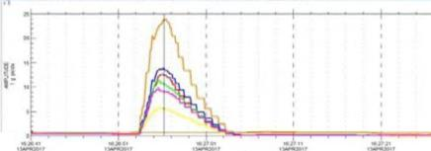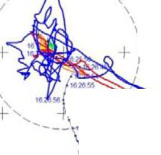

**DIGITALISATION AND AI**

*by: Gaia Rossi, Thorsten Bickmann, Fayyaz Qureshi- Bently Nevada, a Baker Hughes business*

The crosshead acceleration trends were checked, and it was noticed that throw 2 (closer to pump end) crosshead vibration went highest compared to the rest; the amplitude increased from a nominal 0.8g pk to 24g pk in 3 seconds which confirmed that the failure has happened in throw 2.

The impact happened when the disconnected piston rod hit the freely hanging piston inside the cylinder as shown below in Figures 21 and 22 (in crosshead orange filtered waveform). It is interesting to note that API 670 (5th Edition) recommended shutdown parameters (crankcase and crosshead vibration) were not sufficient to save the machine from piston rod failure.

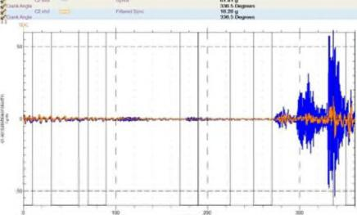

***teal"* •**

*Figure 21: Throw 2 crosshead vibration filtered acceleration (orange) at point of suspected piston rod failure*

*Figure 22: Throw 2 waterfall of crosshead filtered acceleration, cursor (red) at point of suspected piston rod failure*

The only parameters that showed a gradual change over time were rod position magnitude and peak-to-peak displacement (piston rod vibration). In Figure 23, the green rod position waveform shows a smaller

position magnitude close to the bore center. Nine minutes before the failure, it can be noticed that even the rod flexing (piston rod vibration) in vertical and horizontal axis both was nominal. However, just before the failure (blue waveform), the rod flexing increased significantly in the horizontal direction. It is suspected that the crack in piston rod was lateral and not perpendicular, which would have caused the vertical piston rod vibration to increase.

**611 C2 rorl -: -o So6 (-160,11,$)13APP201V*1113**

**Ii *C2* bort** 0117

**m5 MAKE TIP From 134752011 16 11 00 To 13APR2017 10 30 00**

**1nol. *orb i I o I polo.* plan**

*manually overlaid on bore centerline plot*

The peak-to-peak displacement trends (Figure 24) in both vertical and horizontal directions confirmed that the machine could have been safely shut down two minutes prior to the piston rod breakage, if a careful alarm at 400µm peak-peak and automatic trip setpoints at 650 µm peak-peak would have been configured. Expensive repairs on crosshead as a secondary damage could have been avoided.

tem.. et metre

|  |  |  |  |  |
| --- | --- | --- | --- | --- |
| *i*  I.. |  |  |  | 1_ 1_ -I |
| *"..„,,.............-.7-*  *.......-..r*  *1'*  *..* ..... t2:'.' ''. i* 1 | *....... .......'*  *'''.".*  *...* | *"*  _l |
| I I |  |  |
| ::= |
|  |
| zz, 4,;,,,,,,,.. ,v,40,, | | ,=,,,• . | .  ::,,‘111,,, ,=, | |
| **elMma Mir ter im MO ttab Melo**  Meru **ram ...ewe *•••••••* ottlereartr • tam**  ***nee*** | |  | **VileblaMb WM.. le talt**  **'Meal mem t ,-..--: .7-.** | |
|  |  |  |  |  |
|  |  |  |
|  |  |  |
| r |  |  |
|  |  |

*Figure 24: Trend of piston rod peak-peak   
displacement, throw 2 (top: vertical, bottom:   
horizontal)*

API recommendations have matured over the years; in 2007, API 618 (5th Ed.) only recommended crankcase/frame vibration as automatic shutdown parameters and then in 2014, due to several case studies/lessons learnt across the globe, API 670 (5th

* **• • •••••• •• •**

**t••• mom**

**loot • no. matoMoto •m, at at twaltleit •**

**,• gime**

**we, toe memo, me. *•* pry., *u***

***...nor...sow au •***

**Memel. tramb er • VI**

**MM., IMM•   
***.*-***... Tony.. la tem ma.•**

**tialterit Oblate M•**

* **=Noma team ••• a m**

**refeeelt et We • al e m *ate* • ttmom• • mom**

**ntrm•**

**mem.. nem. *14•Ilma.•***

**Mem.   
In OM   
tIte**

**•**

*Figure 20: Crosshead vibration trend of all six*

*throws*

**Moloncal**

uP

**I 325.7 307* 13APR2017 16 18 23 44S!,303. 13AP112011 16 2529 51174011 13APR2017 16 25 19 issoitir 13.10622011 10 20 49 1075.C110.13A7M2017 16**1**26 53**

4-

1

**16 26 56**

**1026 57 16 26 55**

**lam%**

**so *7627*01 6 27 15**

1n 7**A9**

**2000**

**20O0** 0 **10) 2000**

***AMR* Mrk NM Loom.**

*Figure 23: Cylinder 2 Piston Rod waveforms*

**2003**

-t

I

**F**

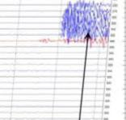

134

**I15 7 of )37 0.6.6.,**

*— - _*

I **DIGITALISATION AND AI 95 I**

*by: Gaia Rossi, Thorsten Bickmann, Fayyaz Qureshi- Bently Nevada, a Baker Hughes business*

Ed.) added crosshead vibration also as a shutdown parameter. The journey continues as operators and condition monitoring solutions vendors partner together in identifying unconventional failure modes on reciprocating compressors with some novel useful parameters like piston rod vibration and understand the behavior of these intricated machines better through extensive data analysis and domain knowledge.

**3.4 Piston ring failure**

The crosshead vibration at stage 2A of a four-throw hydrogen compressor increased beyond 4g pk (alarm setpoint was 2g pk).

*Figure 25: Crosshead vibration trend*

Simultaneously, the piston rod vibration increased above the configured setpoints of 500µm pp in both vertical and horizontal directions, as shown in the next figure.

*Figure 26: Trend stage 2A piston rod peak-peak displacement (blue: horizontal, orange: vertical)*

On the other hand, the crankcase vibration did show a very slight increase with variations, but still was much lower than the configured setpoint. This proves the fact that crankcase vibration alone may not be sufficient for machine protection.

**•**

**wsmi *ow I:L.'* • fruliNFM**

**mallows.**

**.....r•••••••,,,,,zi• •••••••••Ildl ••••• •**

**•••• Meallillinels.,•••••••.••••••** AIM • MOO • %WS

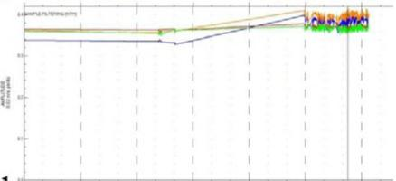

*Figure 27: Crankcase vibration trend*

Dynamic data in Figure 28 was referred for further investigation into the root cause of this high crosshead and piston rod vibration. Crossover in the HE pressure curves (adiabatic and actual) in the second part of the plot delineated a piston ring failure (crossover should also show up in CE pressure curve, however the discharge valve leakage masked that, due to the severe leaking). High-3-2000 Hz filtered crosshead vibration (orange waveform in third part of the plot) confirmed vibration generated by mechanical impacts, which can be due to broken particles of piston rings coming underneath the piston. Changes in piston rod displacement (bottom plot of Figure 28) show that the piston lifted up due to piston ring pieces getting trapped on the sides of the piston.

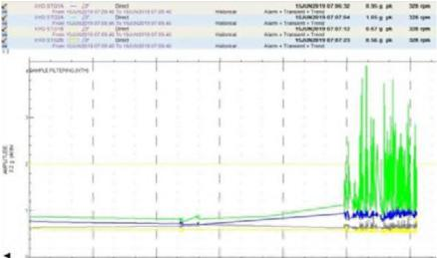

**nesnw - sr Of IN 1 VIGO 'MOW**

**Wonire,104.7....r..10.0 • •• • IP**

**40••• M. gm**

**Imm ••••• nowiremo • •• SW RIM**

41.....EM.,00•1Pret

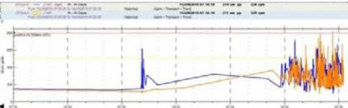

**\*\*kb Li..• aro.**

**Illo••••••••••01**

**Minna. me MM.. gm...**

**0•••••••••• n••••••ROM *wawa* ••••••••••••••**

•

1—

**DIGITALISATION AND AI**

*by: Gaia Rossi, Thorsten Bickmann, Fayyaz Qureshi- Bently Nevada, a Baker Hughes business*

|  |  |  |  |  |  |
| --- | --- | --- | --- | --- | --- |
| ***.e***  **...,00.**  **. _**  **UV** | | **00 nIt o0.0.0•3000009.17** | | **411•09 NI**  **99 099,999**  **Aroma sae  M.* VI ••• 11•9990 mum" -Mil MI**   * **9 Oyu= mown** | **01.•••• • 909I 100**  **lb M.0** |
|  |  |  |  |  |  |
|  |  |
|  |
|  |  |
|  |
|  | **MO** | **29 Coro*: *fro. i k aue•*** |  | ***MO*** |
| ***.1 r 6....,***  ***..•***  ***.5.2....***  ***VC.A.e* 99 9.09**  **aa** | |  | ***......*** | * ***• bele ••300..0'•!*** * ***• •ftem***   ***.42.4.***  **SS *0* WM".**  **.,a.—** |  |
| **6**  **,.,1 .**  **:.** |  |  |  |  |  |
| **—**  **i** | **i..—**  **i---** | **,**  **.** |
|  |  | **.** |  |  |
|  | * **. .** | r | x11 **4090090**  **4090 0900** | **•** | z0 |

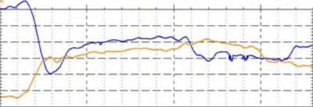

standards, piston rod peak to peak displacement provides vital information about the running gear health and, being a very reliable and stable parameter, it can be made part of the trip logic, to ensure comprehensive protection. A careful study of compressor baseline data at different operating conditions may help define optimal setpoints to save machines from impending primary and secondary failures. The review of dynamic data supports the identification of developing faults from the very outset by pinpointing the failing components and by determining severity. With this help, machine shutdowns can be scheduled efficiently with minimal spare inventory.

**References**

EFRC R&D project on Compressor Reliability Survey (2010)

**2** Fayyaz Qureshi, Thorsten Bickmann (2018): Online Condition Monitoring System identifies developing faults in reciprocating compressors at the very outset, ADIPEC

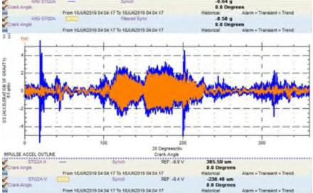

**•**

**66 0••••••**

**El**

**1 *09*10—••**

**I1.000**

**II•• 9900112319 OM Mb %NOM MM II**

**00990.000**

**km MUM* MO .A fM«U**

***Amoco***

* **14 •   
  9.911•939•5**

**0•09999, Afte•• • 00••• • o.**

**WAXY 9C399.43091.003**

**hem 199199.911919 071 MAIYIIMY**II

**n•1.. 19.9 4.19   
0Aala**

**1.099 99.909101919.90 010 Ili id**

***—***

**Wt. INF Sly *216911•00***

**9.9 LI•909=**

**.990•900 ye. • INA.. • To*   
..219 Im**

* **PAP..**
* **90..009 Awe .9.9. • 9.009**

**300**

**20 Oyu* en. .940,**

**390** Ye **20 90000.0..**

*Figure 28: Dynamic sample for Stage 2A*

Inspections showed that the piston rings were found broken as shown in Figure 29. Thus, the condition monitoring system was able to identify and pinpoint to failures as soon as they happened. The machine was shut down safely and that saved from expensive secondary failure(s) and extended downtime.

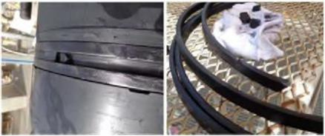

*Figure 29: Broken piston rings*

**6 Conclusion**

In addition to crankcase and crosshead vibration as recommended shutdown parameters by API